**Which location is better to open Cocktail Bar Cracow or Warsaw?**

1. **A description of the problem and a discussion of the background.**

In my analysis I will be exploring which of the two of Polish cities Cracow and Warsaw might be better to open a Cocktail Bar in. My sister in law is considering in investing in such venue in one of the cities and this analysis is supposed to help her make decision which location might be better.

Warsaw is a modern capital of Poland however Cracow is known as a historic capital with a lot of charm. Two cities have different character however both have old town, both attract tourists and both are large enough to generate footfall form local population.

I’m interested to learn which of these cities would be better to base Cocktail Bar in. In order to maximise the success of the venue it would be beneficial to base it close to attractions and old town, therefore I’m also interested whether it might be a good idea to base Cocktail Bar close to old town.

1. **A description of the data and how it will be used to solve the problem.**

I’ll use statistics such as population, GPD, total number of tourist visiting available on Wikipedia and PWC reports published online. This data would give me generic picture of the city and its potential. From this data I will get a view of weather I can expect profits to be driven by local population or tourists and how busy the city is and which city has population which is more likely to have a spare cash to spend on entertainment. This data will help me determine which city has potentially better suited audience for venue I’m planning to open.

To evaluate location of Cocktail bar I will use data available on Foursquare. I will lookup venues within 10k of old town coordinates for each city. I will first search for Cocktail Cars to see how saturated the market is in general and then I’ll explore how many bars there is in the same proximity to old town. By searching bars I would like to know how many venues serving alcohol I’ll be competing against.

1. **Methodology**

* Explanatory analysis of statistics about Warsaw and Cracow will be conducted and bar charts used to compare statistics about the cities.
* In order to learn about proximity of competitive venues to old town data obtained from Foursquere about location of these venues will be visualised on map.
* Data visualisation will be conduced using Folium package

1. **Results and discussion**

* Warsaw has higher population and GDP per capita

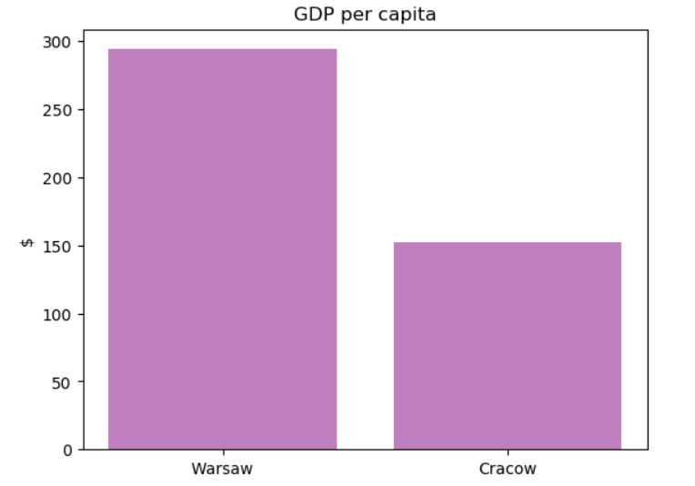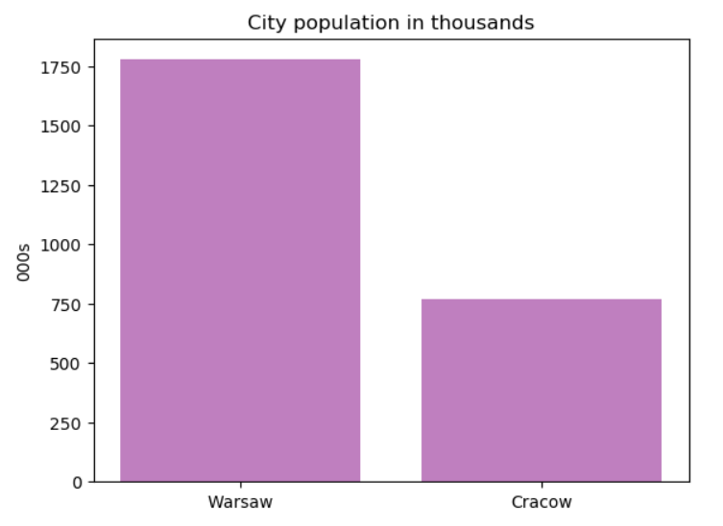

* Warsaw has higher number of total tourists but Cracow has slightly higher number of foreign tourists

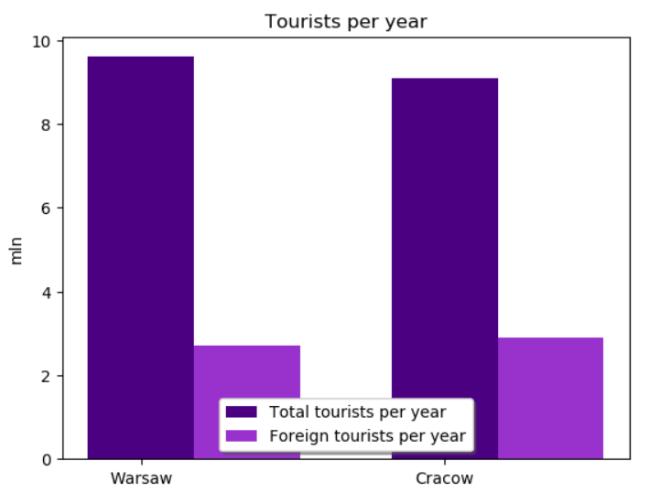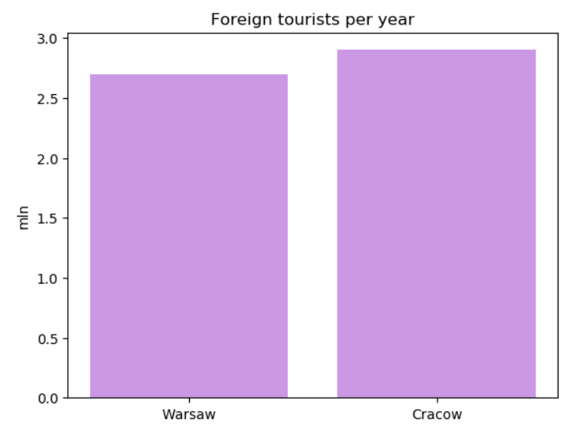

* In Warsaw there is 10 bars specialising in cocktails but none of them is near old town

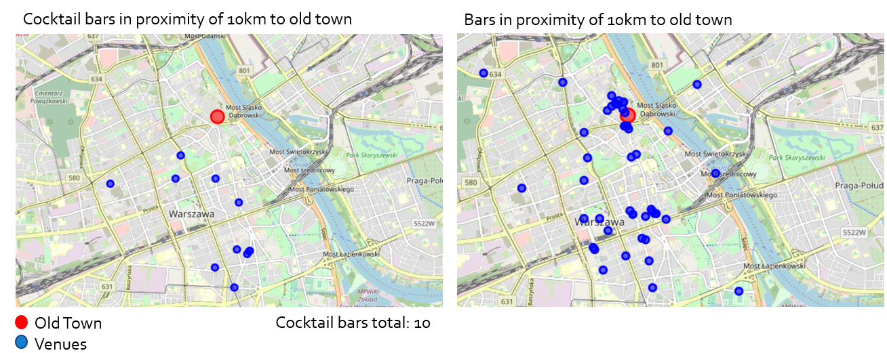

* There is less cocktail bars in Cracow but old town is highly saturated with bars

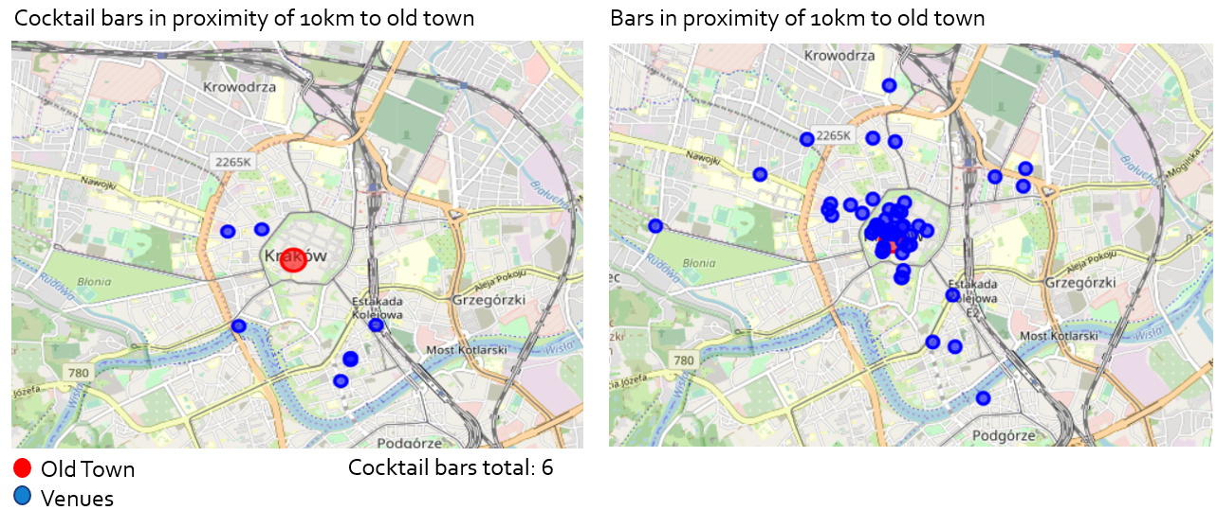

1. **Conclusion**

* There is more foreign tourists in Cracow which might be good for footfall but market is quite saturated with bars already. Also city has lower GDP than Warsaw, therefore Cracow is dismissed as an investment option.
* Warsaw has higher GDP and also higher total number of tourist. Also location around old town is not as saturated as Cracow. Also there is no cocktail bar in old town therefore Warsaw gets go ahead for investment.